Project 1.

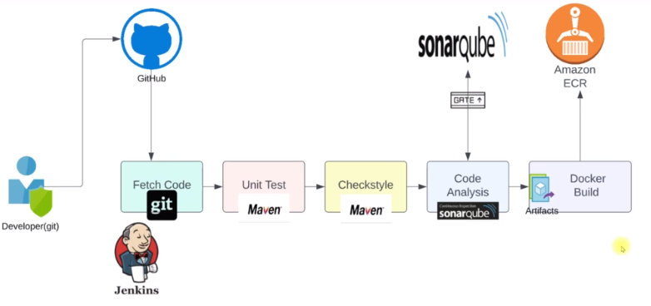

Project 2. High availability with the security provision.

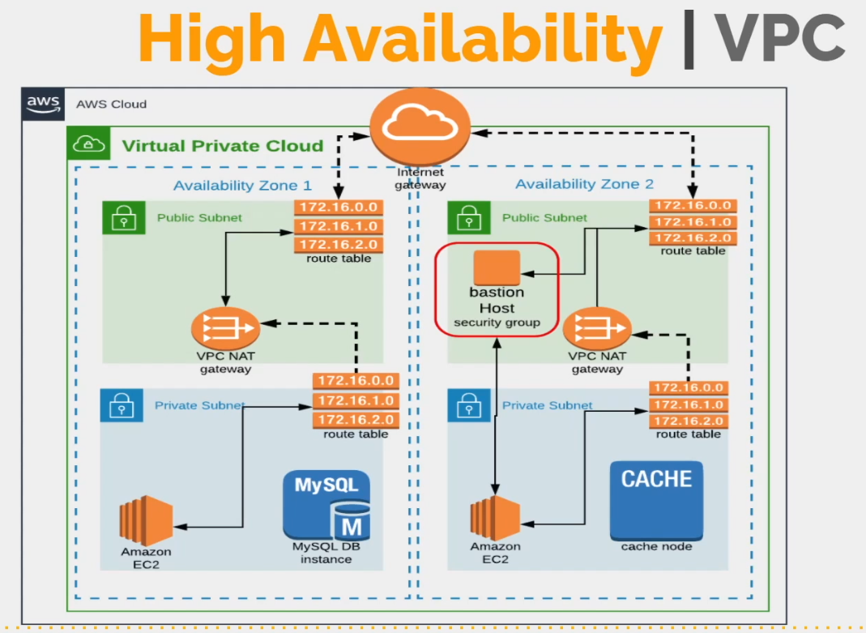

Project 3 – Full AWS CI/CD Java Project. Beanstalk.

